Component 1: Checklist

Student Name/ID: Arpan Piya/ C7202317

Development Choice: Visual Studio Code / XAMPP

Add Screenshots to show successful setup – project window should show supplied case study
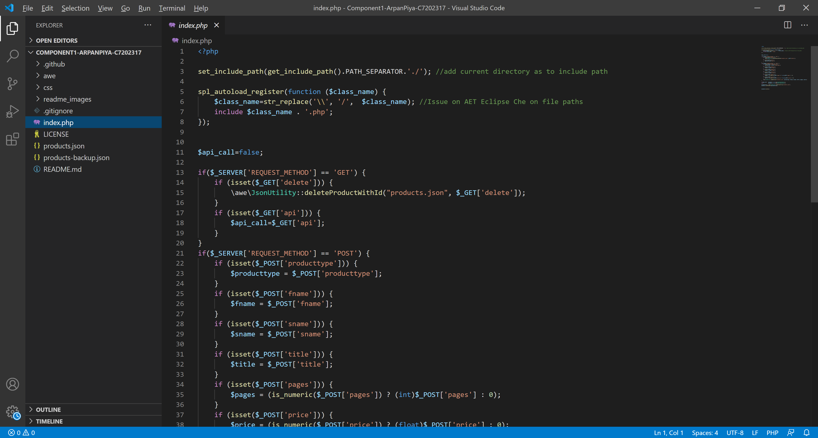
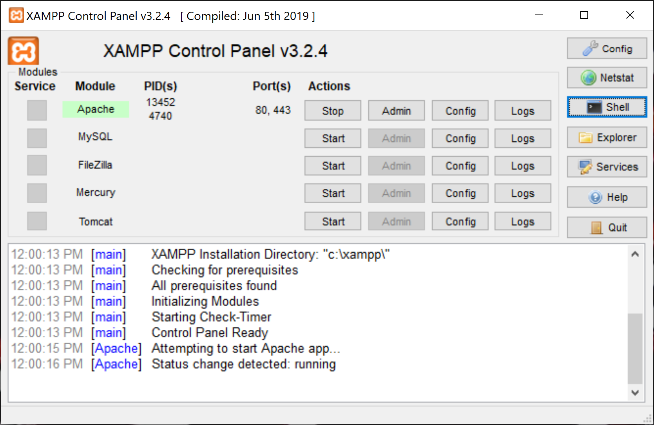

PHP Version being used: ‘7.4.10’

XDebug installed: Yes
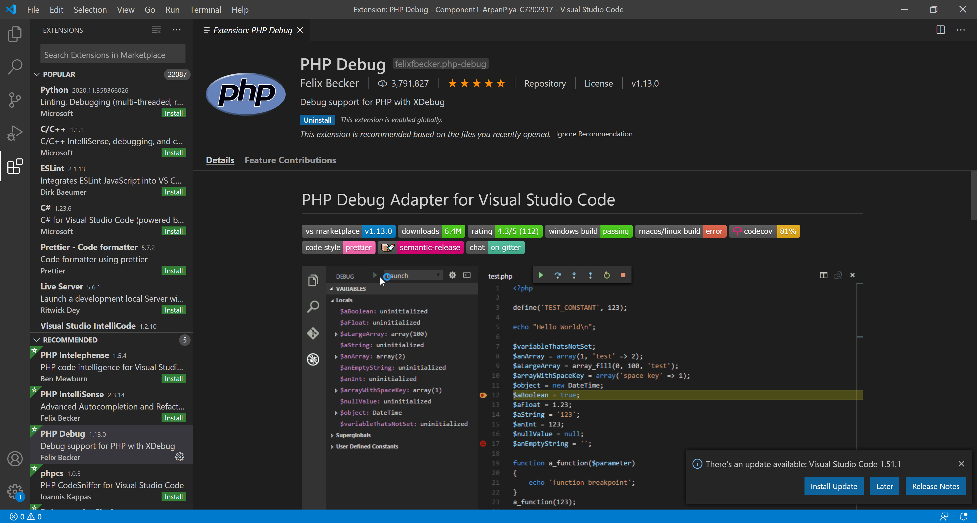

(Add screenshot of output of php –v)
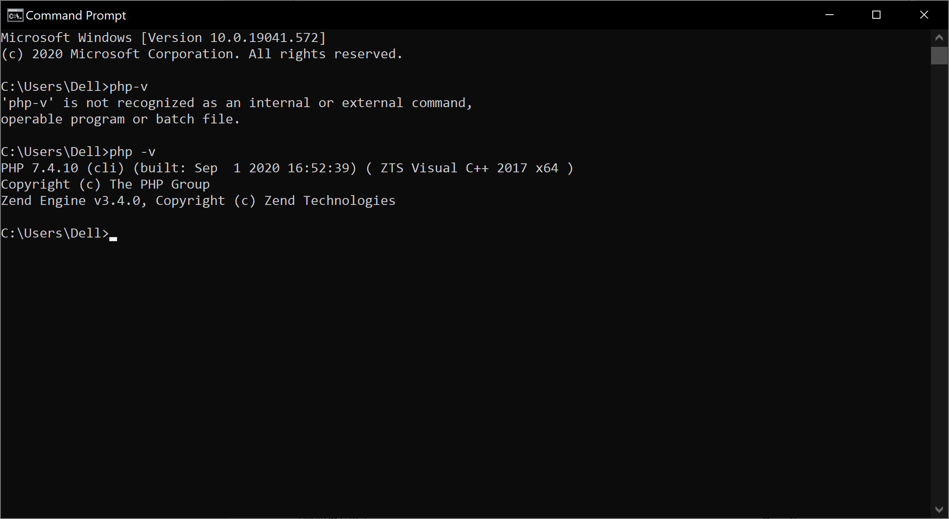

Composer:

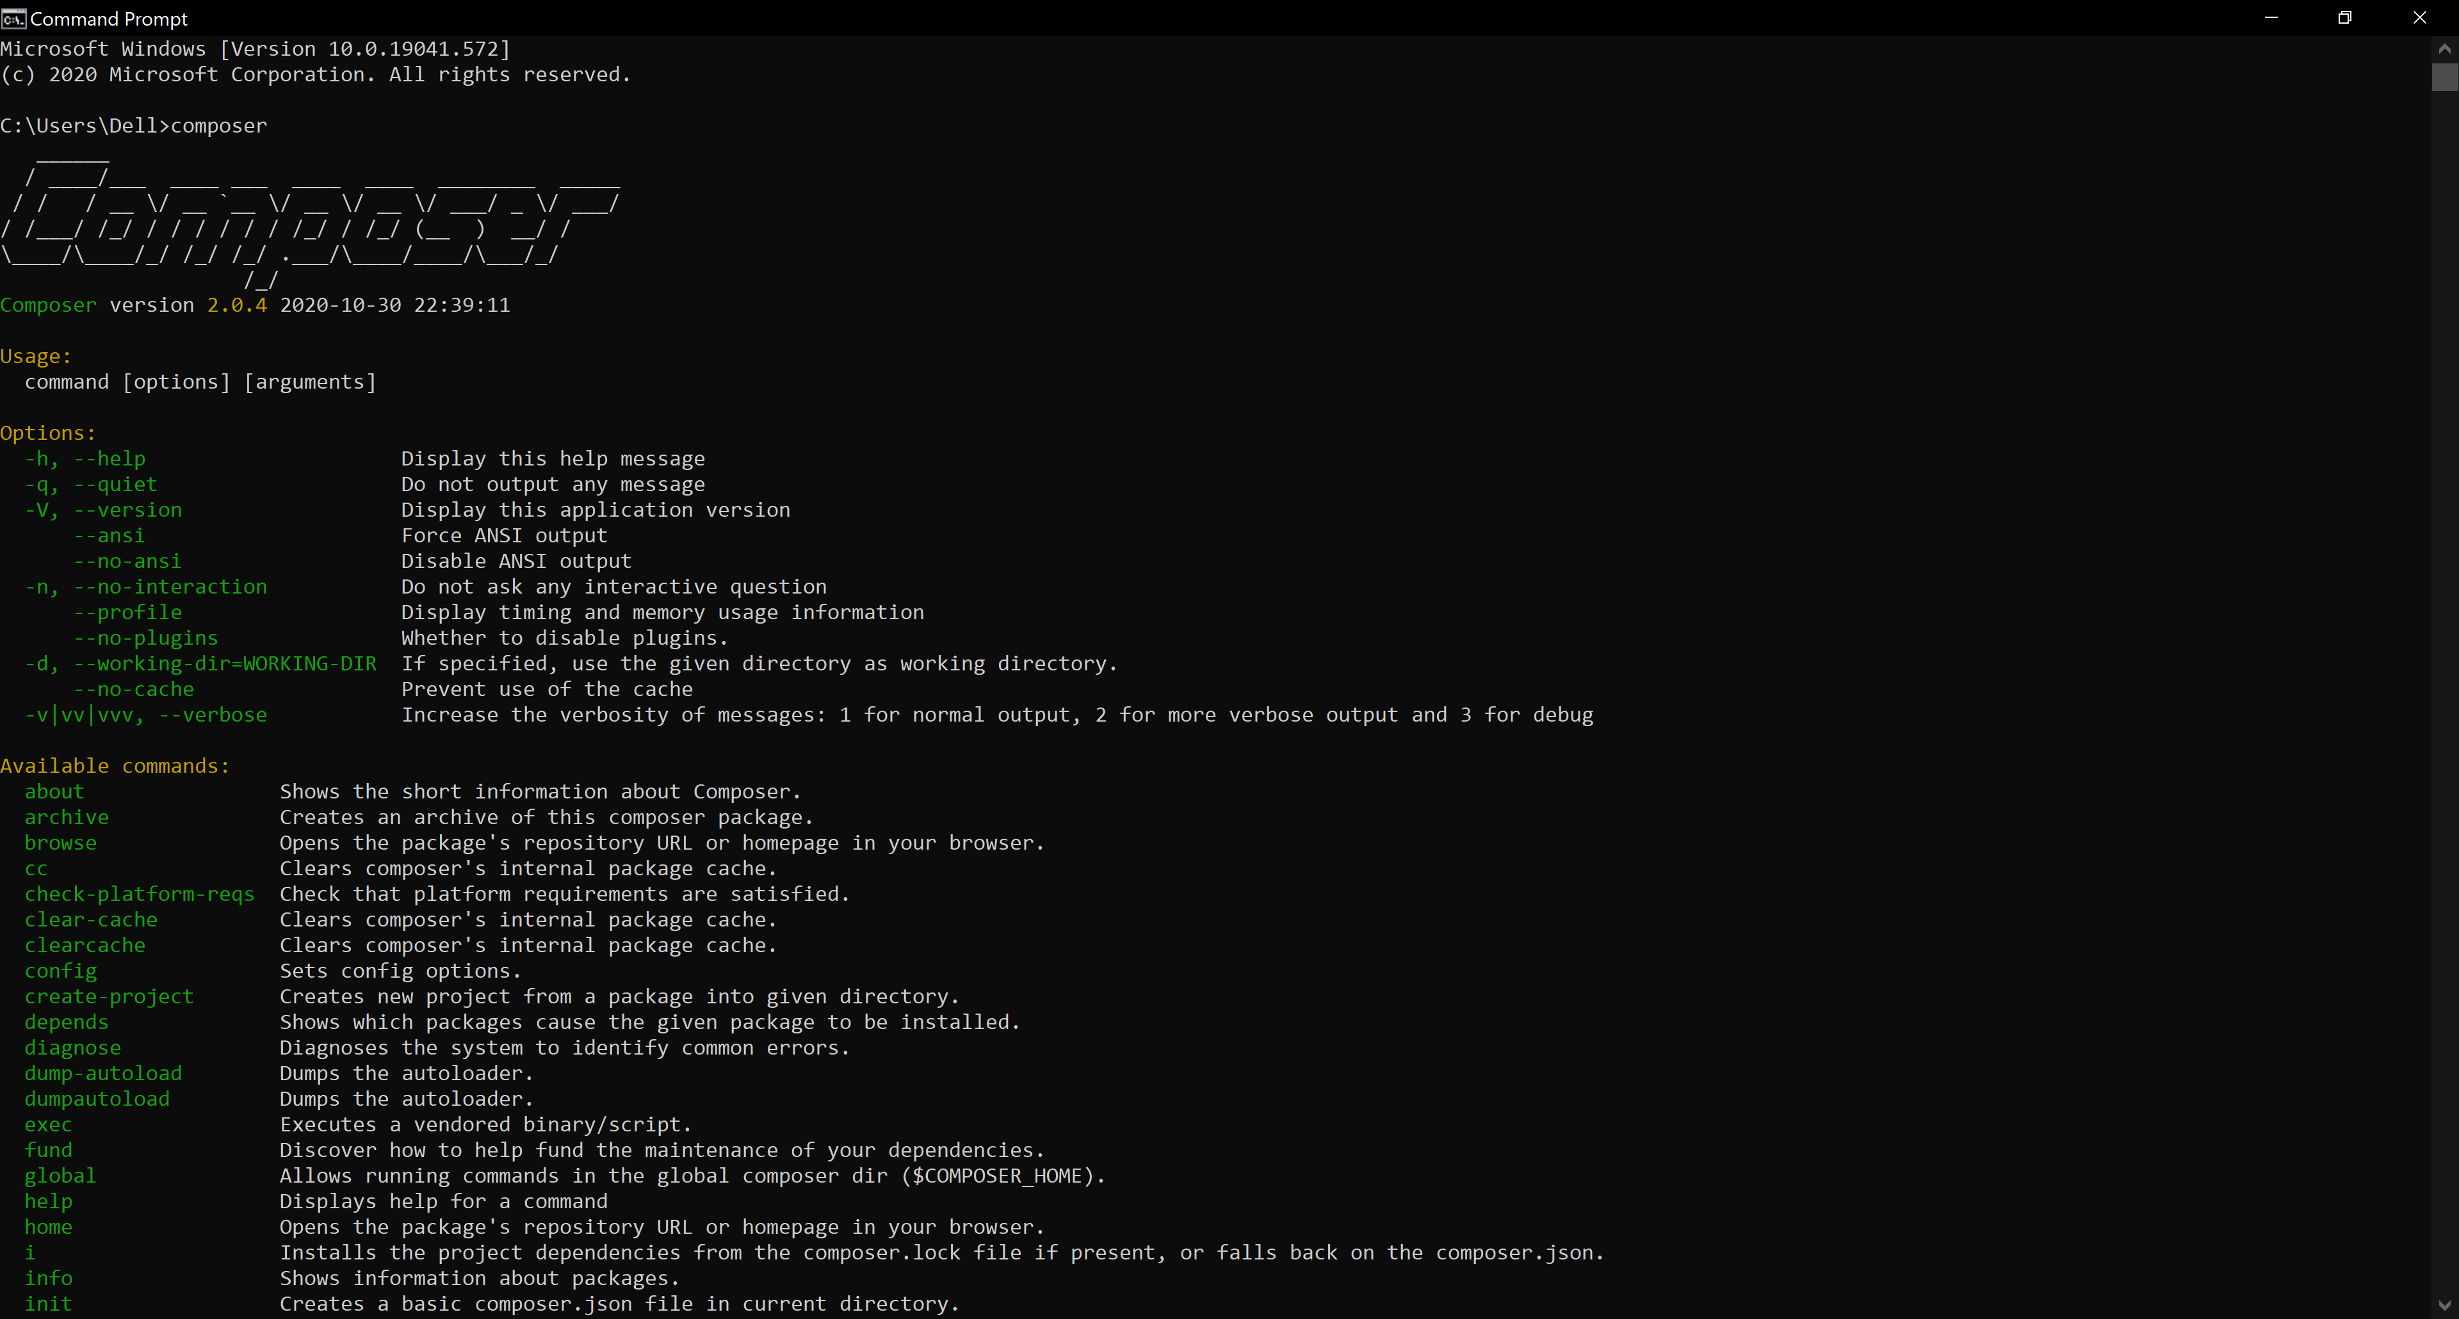

Laravel:

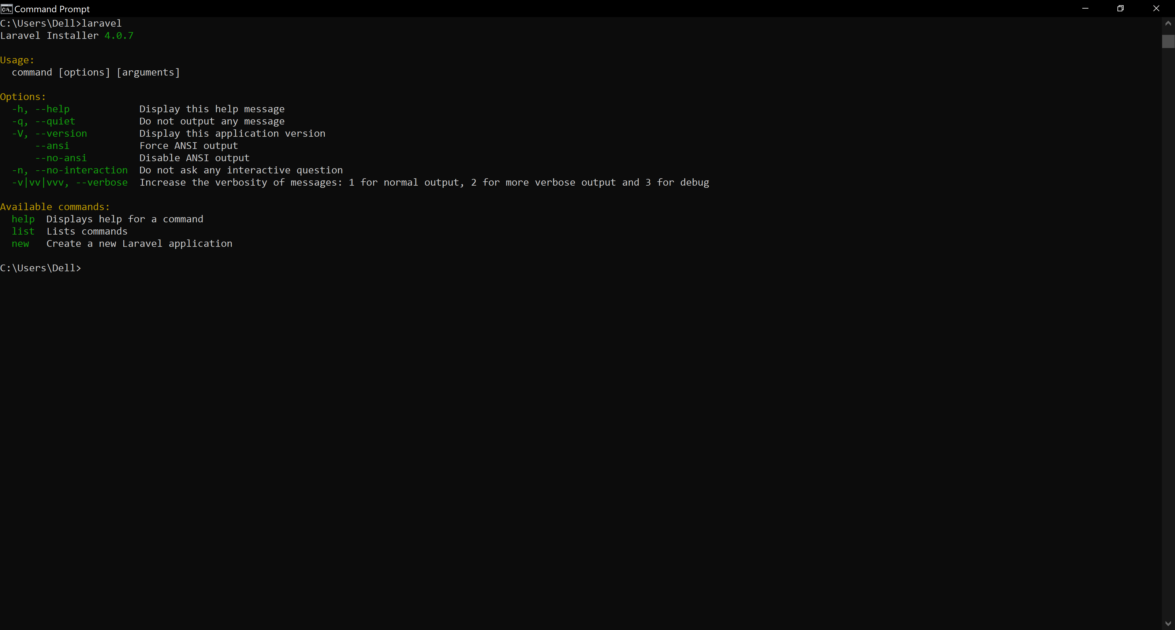

Git Clone
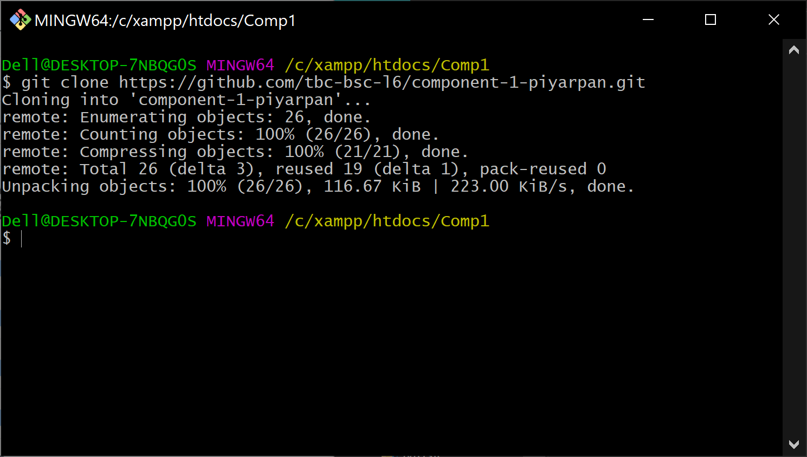

Git email: piyarpan@gmail.com
Git username: piyarpan
Git account created and used: ‘replace with URL of GitHub repository’

https://github.com/tbc-bsc-l6/component-1-piyarpan.git

Remaining marks are awarded for completion of the short PHP exercise
